# CSC242 Introduction to Programming Concepts Week Two Assignment

| **First Name** |  |
| --- | --- |
| **Last Name** |  |
| **ID#** |  |
| **Email Address** |  |

Table of Contents

How to submit your Assignment 2

P1 – Geometry: Area of a Regular Polygon 2

P2 – Table of Squares and Cubes 3

P3 – Diamond Printing Program 3

P4 – Common Characters of two Strings 4

P5 – Factorial 5

P6 – Calculate *e* 5

# 

# How to submit your Assignment

Robert Joseph Dykes 041502945

After filling all the parts in this file, please follow the following steps.

1. Add your name and ID to the first page.
2. Save the file in the original format (Docx or Doc)

(please do not convert to other file formats e.g. PDF, ZIP, RAR, …).

1. Rename the file as

CSC242 *–* ***HW2*** *- ID – YOUR Last Name - YOUR First Name.docx*

**Example:** CSC242 *–* ***HW2*** *-* 234566435 - Smith - John.docx

1. Upload the file and submit it (only using Blackboard)

# P1 – Geometry: Area of a Regular Polygon

A regular polygon is an n-sided polygon in which all sides are of the same length and all angles have the same degree (i.e., the polygon is both equilateral and equiangular). The formula for computing the area of a regular polygon is

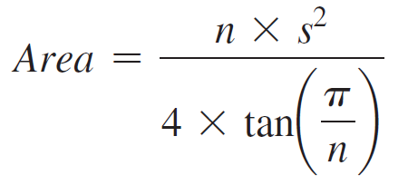

Here, *s* is the length of a side.

Write a program that prompts the user to enter the number of sides and their length of a regular polygon and displays its area. Here is a sample run:

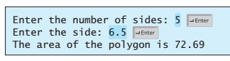

|  |
| --- |
| Your C++ code for this problem |
| #include <iostream>  #include <cmath>  using namespace std;  int main() {  double n, s;    cout << "Please enter the number of sides and the length of all sides, seperated by space and press enter" << endl;  cin >> n >> s;  double area = (n * pow(s, 2)) / (4 * tan(3.14159 / n));  cout << "The area of the polygon is "<< area << endl;  return 0;  } |

Run the code and insert the result in the following box.

|  |
| --- |
| The run result |
|  |

# P2 – Table of Squares and Cubes

Use the loops to write a program that calculates the squares and cubes of the numbers from 0 to 10 and prints the resulting values in table format, as shown below.

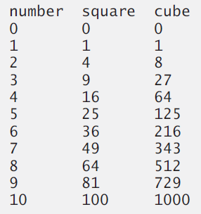

|  |
| --- |
| Your C++ code for this problem |
| #include <iostream>  #include <iomanip>  #include <cmath>  using namespace std;  int main() {  double num;    cout << setw(8) << left << "number" << setw(8) << "square" << setw(5) << "cube" << endl;  for (num = 1; num <= 10; num++) {  cout << setw(8) << left << num << setw(8) << pow(num, 2) << setw(5) << pow(num, 3) << endl;  }  } |

Run the code and insert the result in the following box.

|  |
| --- |
| The run result |
|  |

# P3 – Diamond Printing Program

Use the loops to write an application that prints the following diamond shape.

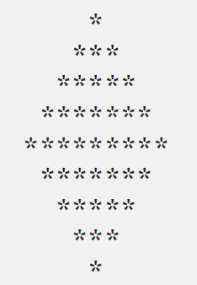

|  |
| --- |
| Your C++ code for this problem |
| #include <iomanip>  #include <iostream>  #include <cmath>  using namespace std;  int main() {  string star = "*";  string twoStars = "**";  int width = 20;  int i;  for (i = 0; i < 9; i++){  cout << setw(width) << star << setw(width) << endl;  if (i < 4) {  star += twoStars;  width++;  }  else if (i >= 4 && i < 8) {  star.resize(star.length() - 2);  width--;  }  }  return 0;  } |

Run the code and insert the result in the following box.

|  |
| --- |
| The run result |
|  |

# P4 – Common Characters of two Strings

Write a program that prompts the user to enter two strings and then find the common characters of the two strings and displays them.

Example:

string1 = “Hello”

string1 = “pilot”

Common Characters = lo

|  |
| --- |
| Your C++ code for this problem |
| #include <iostream>  #include <cctype>  using namespace std;  int main() {  string firstString;  string secondString;  cout << "Please enter string 1 (only letter characters with no spaces):" << endl;  cin >> firstString;  cout << "Please enter string 2 (only letter characters with no spaces):" << endl;  cin >> secondString;  int i;  int j;  string firAnswer;  for (i = 0; i <= firstString.length() - 1; i++) {  for (j = 0; j <= secondString.length() - 1; j++) {  if (secondString.at(j) == firstString.at(i)) {  firAnswer += secondString.at(j);  }  }  }  string alphStr = "abcdefghijklmnopqrstuvwxyz";  int k;  int l;  string finalAnswer;  for (k = 0; k < alphStr.length() - 1; k++) {  for (l = 0; l < firAnswer.length() - 1; l++) {  if (firAnswer.at(l) == alphStr.at(k)) {  finalAnswer += alphStr.at(k);  break;  }  }  }  cout << "the common characters are " << finalAnswer << endl;    return 0;  } |

Run the code and insert the result in the following box.

|  |
| --- |
| The run result |
|  |

# 

# P5 – Factorial

The factorial of a nonnegative integer n is written as n! (pronounced “n factorial”)

and is defined as follows:

*n! = n · (n – 1) · (n – 2) · … · 1* (for values of n greater than or equal to 1)

and

*n! = 1 (for n = 0)*

For example, 5! = 5 * 4 * 3 * 2 * 1, which is 120.

Write a program that reads a nonnegative integer and computes and prints its factorial.

|  |
| --- |
| Your C++ code for this problem |
| #include <iostream>  using namespace std;  int main() {  double usernum;  double i;  cout << "Please enter a non negative whole number" << endl;  cin >> usernum;  double factorial = usernum;  for (i = usernum; i > 1; i--) {  factorial *= (i - 1);  }  cout << "The factorial of " << usernum << " is " << factorial << endl;  return 0;  } |

Run the code and insert the result in the following box.

|  |
| --- |
| The run result |
|  |

# P6 – Calculate *e*

Use the factorial program in the previous problem and extend it to write a program that estimates the value of the mathematical constant *e* by using the following formula. Allow the user to enter the number of terms to calculate.

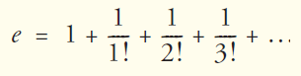

|  |
| --- |
| Your C++ code for this problem |
| #include <iostream>  using namespace std;  double fun(double y) {  double factorial = y;  int i;  for (i = y; i > 1; i--) {  factorial *= (i - 1);  }  return factorial;  }  int main() {  int termNum;  cout << "How many terms would you like to calculate? (please enter only whole positive numbers)" << endl;  cin >> termNum;  int i;  double answer = 1 + (1 / fun(termNum));  for (i = termNum; i > 1; i--) {  answer += (1 / fun(i - 1));  }  cout << "The answer is " << answer << endl;  return 0;  } |

Run the code and insert the result in the following box.

|  |
| --- |
| The run result |
|  |

**The end**